

**Homework #8**

**01286121 Computer Programming**

**Software Engineering Program,**

**Department of Computer Engineering,**

**School of Engineering, KMITL**

By

66011149 Phatthadon Sornplang

1. We are going to do some conversions, from integer to binary and then from binary back to integer. It will give us a chance to play with if-elif-else and while statements, as well as a little string slicing.

**Your Task**

Prompt for an integer input, convert the integer to a binary number string (there is no type for actual binary numbers so we just represent it as a string). We then take the string and turn it back into a regular integer.

while True:

inpus = input("Enter an integer: ")

try:

x = int(inpus)

except ValueError:

print("Invalid input")

if x < 0:

print("Only positive integers are allowed")

break

if x == 0:

print("It is 0")

break

b =[]

while(x>0):

d = x%2

b.append(d)

x = x//2

b.reverse()

print("The binary equivalent of the number is ")

for i in b:

print(i,end="")

b.reverse()

j = len(b)

i = 0

y = 0

while i < j :

y += 2**i * b[i]

i += 1

print("\n")

print("Converted back to integer,",y,"\n")

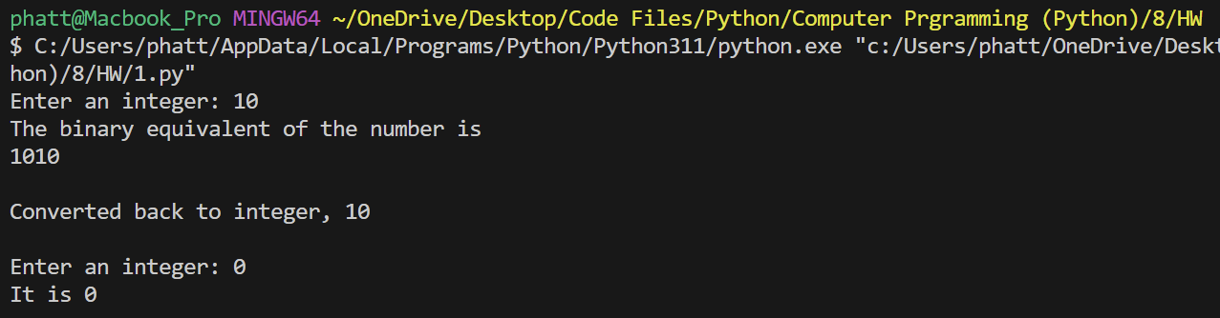

2. Write a Python program for reading a string from the user then printing the frequency distribution of each character occurring in the string (that is, the percentage of the length of the whole string).

x = input("Enter some text: ")

len = len(x)

char_count = {}

for i in x:

if i in char_count:

char_count[i] += 1

else:

char_count[i] = 1

print("-- Character Frequency Table --")

for char, count in char_count.items():

percent= (count / len) * 100

print(f"{char} = {percent:.2f}%")

3. Write a Python program for reading a string from the user then drawing a bar graph for the count of each character occurring in the string using the turtle module. Note: each bar has the height of 20 times of its character count, and the height of the vertical axis will be the same as the height of the tallest bar.

import turtle as t

x = input("Enter some text: ")

len1 = len(x)

char_count = {}

value = []

chars = []

for i in x:

if i in char_count:

char_count[i] += 1

else:

char_count[i] = 1

lencnt = len(char_count)

for char, count in char_count.items():

chars.append(char)

value.append(count)

maxi = max(value)

t.penup()

t.goto(-20*lencnt,0)

t.pendown()

t.left(90)

t.fd(20 * maxi)

t.left(90)

t.fillcolor("black")

t.begin_fill()

t.fd(5)

t.right(120)

t.fd(10)

t.right(120)

t.fd(10)

t.right(120)

t.fd(10)

t.end_fill()

t.penup()

t.goto(-20 * lencnt,0)

t.pendown()

t.right(180)

t.fd((30 * lencnt)+ 30)

t.left(90)

t.fillcolor("black")

t.begin_fill()

t.fd(5)

t.right(120)

t.fd(10)

t.right(120)

t.fd(10)

t.right(120)

t.fd(10)

t.end_fill()

t.penup()

t.goto(-20 * lencnt,0)

t.pendown()

t.right(90)

for i in range(lencnt):

t.fd(20)

t.penup()

pos1 = t.xcor()

pos2 = t.ycor()

t.goto(pos1 +5,pos2 -20)

t.pendown()

t.write(chars[i])

t.penup()

t.goto(pos1,pos2)

t.pendown()

t.left(90)

t.fd(value[i] *20)

t.right(90)

t.fd(10)

t.right(90)

t.fd(value[i] *20)

t.left(90)

t.hideturtle()

t.done()

4. An ISBN-10 (International Standard Book Number) consists of 10 digits:.The last digit, d10, is checksum

x = (input("Enter the first 9 digits of an ISBN-10 as a string:"))

if len(x) >= 10 or len(x) < 9:

print("Invalid input")

checksum = (int(x[0]) * 1 + int(x[1]) * 2 + int(x[2]) * 3 + int(x[3]) * 4 + int(x[4]) * 5 + int(x[5]) * 6 + int(x[6]) * 7 + int(x[7]) * 8 + int(x[8]) * 9) % 11

if checksum == 10:

print(f"Your ISBN-10 number is {x}X")

else:

print(f"Your ISBN-10 number is {x}{checksum}")

